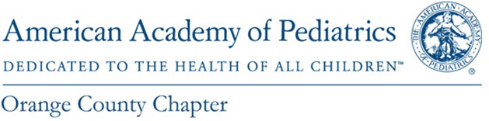
Early Childhood Obesity Forum

Program Agenda

Saturday, February 9, 2019

8:00 AM – 11:30 AM

8:00 AM – 8:30 AM | Registration and Breakfast
8:30 AM | Welcome and Introductions  Maria Minon, MD, Sr. VP Medical Affairs & Chief Medical Officer – CHOC Children’s Hospital
8:35 AM – 8:50 AM | Introductions and Activity  Michael Weiss, DO, VP Population Health, CHOC Health Alliance  Candice Taylor Lucas, MD, Asst. Clinical Professor at UCI School of Medicine & Dept. of Pediatrics  Arlene Turner, MS, Physical Activity Specialist, Consultant for CFCOC
8:50 AM – 9:05 AM | The State of Obesity in Orange County  Dan Cooper, MD, Associate Vice Chancellor for Clinical & Translational Science
9:05 AM – 10:05 AM | Promoting Positive Parent – Child Interaction for Preventing and Managing Obesity  Marta M. Shinn, PhD, UC Davis PCIT Training Consultant & Implementation Specialist
10:05 AM – 10:20 AM | Physical Activity: Integration into Daily Practice
10:20 AM – 10:30 AM | Break
10:30 AM – 11:15 AM | Incorporating Pediatric Obesity Prevention into Your Practice  Panel Discussion  Facilitator – Michael Weiss, DO  Panelists: Arlene Turner, MS  Candice Taylor Lucas, MD  Eric Ball, MD, President of AAP-OC  Laura Bejar, Parent, Aaron’s Mom
11:15 AM – 11:30 AM | Final Thoughts, Evaluation  Candice Taylor Lucas, MD

Thank you for joining us!

